
Symbiosis Institute of Technology, Pune
CSE- Academic Year 2026-27
Java Programming – Lab Batch 2025-29
Lab Assignment No.: 15
Name of Student | Akshit Gawade
PRN No. | 25070122029
Batch | 2025-2029
Class | A1
Academic Year & Semester | Second Year  Semester III
Date of Submission
Title of Assignment: | Write a Java program to demonstrate exception handling using finally, throw, and throws.
Problem Statement  &  Learning  Objective | Problem Statement  Write a Java program to demonstrate exception handling using finally, throw, and throws.  Learning Objectives  To implement finally, throw, and throws for effective exception management
Theory | The finally block always executes regardless of whether an exception occurs, making it suitable for resource cleanup. The throw keyword explicitly generates an exception, while throws declares exceptions that a method may pass to its caller. These mechanisms improve structured error handling and application stability.
Program Code | Main.java:  class InvalidAgeException extends Exception {  public InvalidAgeException(String m) {  super(m);  }  }  public class Main {  public static void validate(int age) throws InvalidAgeException {  if (age < 18) {  throw new InvalidAgeException("Age must be 18 or above");  }  System.out.println("Vlaid age : " + age);  }  public static void main (String[] args) {  try {  validate(12);  } catch (InvalidAgeException e) {  System.out.println("Caught Exception : " + e.getMessage());  }  }  }  ----------------------------------------------------------------------  Main2.java:  public class Main2 {  public static void main (String[] args) {  try {  int[] n = new int[5];  int divisor = 0;  for (int i = 0; i < n.length; i++) {  int res = n[i] / divisor;  System.out.println(res);  }  } catch (ArithmeticException e) {  throw new RuntimeException("Error : Division by zero occured", e);  }  }  }
Output Screenshots | Age input: 12:  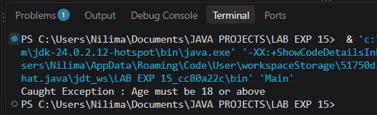  Divisor set to 0:  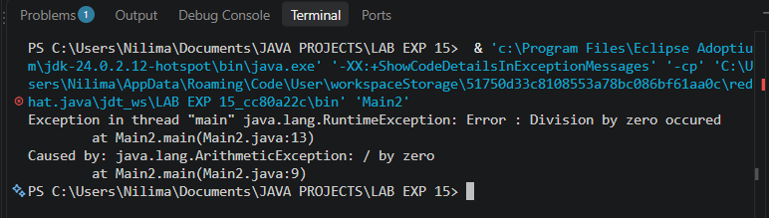
Exercise Qns  and Code | - Create a Login program that throws an exception for invalid password and uses finally block.  import java.util.Scanner;  public class Ex1 {  public static void main (String[] args) {  try (Scanner in = new Scanner(System.in)) {  String correctPassword = "admin123";  try {  System.out.print("Enter Password : ");  String password = in.nextLine();  if (!password.equals(correctPassword)) {  throw new Exception("Invalid Password!");  }  System.out.println("Login Successful.");  } catch (Exception e) {  System.out.println("Error: " + e.getMessage());  } finally {  System.out.println("Login process completed.");  }  }  }  }  2. Create an ATM PIN Verification program that throws an exception for an invalid PIN entered by the user and uses a finally block to display a message indicating that the verification process has completed.  import java.util.Scanner;  public class Ex2 {  public static void main (String[] args) {  try (Scanner in = new Scanner(System.in)) {  try {  String pass = "12345";  System.out.print("Enter ATM PIN : ");  String pin = in.next();  if (!pin.equals(pass)) {  throw new Exception("Incorrect ATM PIN!");  }  System.out.println("Logging in...");  System.out.println("ATM Check in Verified!!!");  } catch (Exception e) {  System.out.println("Error: " + e.getMessage());  } finally {  System.out.println("ATM Verification Completed!");  }  }  }  }
Output Screenshots | Ex1:  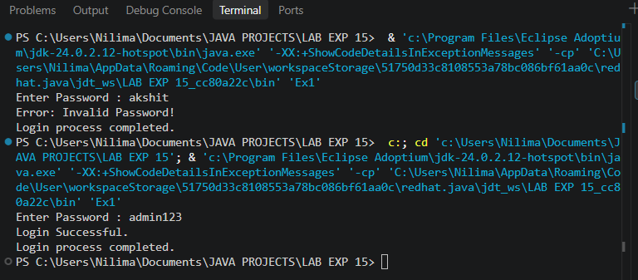  Ex2:  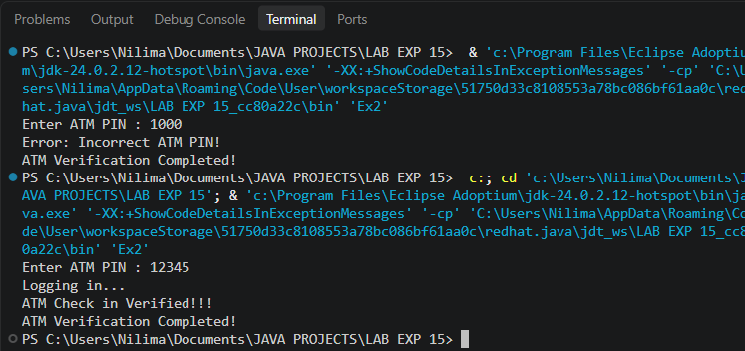
Conclusion | This experiment demonstrates controlled exception propagation and guaranteed resource cleanup. It highlights using throw to trigger exceptions, throws to declare potential caller hazards, and the finally block to execute critical cleanup operations regardless of program execution outcome.

